Subject Name: | Web Technologies
Assignment No.: | 07
Name of the Student: | Khushal Nandkishor Nagpure
Division: | H
Batch: | 3
Roll No: | 35
PRN Number: | 12411564

AIM: To design and develop a responsive full-stack Online Book Store application using React, Spring Boot, and a relational database that allows users to register, log in, browse available books, and manage their book-related information through a user-friendly web interface.
OBJECTIVES:
- To develop a responsive frontend for an Online Book Store using React.
- To develop a robust backend using Spring Boot and RESTful APIs.
- To establish database connectivity for storing and retrieving user and book information.
- To implement user registration and login functionality for registered users.
- To display available books along with relevant details such as title, author, price, and description.
- To implement form validation and appropriate error handling in the application.
- To integrate the React frontend with the Spring Boot backend using REST APIs.
- To use React components, props, state management, and routing appropriately.
- To design a responsive and user-friendly interface that works across desktop and mobile devices.
- To test the REST APIs and verify the complete functionality of the application.
SOFTWARE REQUIREMENTS:
- Operating System: Windows / Linux / macOS
- Frontend: React.js
- Backend: Spring Boot
- Programming Languages: Java, JavaScript
- Database: MySQL/PostgreSQL
- Database Connectivity: Spring Data JPA / Hibernate
- API Architecture: RESTful APIs
- Frontend Routing: React Router
- Package Manager: npm
- Build Tool: Maven
- Development Environment: Visual Studio Code / IntelliJ IDEA / Eclipse
- Web Server: Apache Tomcat (embedded in Spring Boot)
- API Testing Tool: Postman
- Web Browser: Google Chrome / Mozilla Firefox / Microsoft Edge
- Version Control: Git / GitHub (optional)

CODE:
BookController.js:
package com.bookstore.controller;

import com.bookstore.dto.BookDTO;
import com.bookstore.service.BookService;
import jakarta.validation.Valid;
import lombok.RequiredArgsConstructor;
import org.springframework.http.HttpStatus;
import org.springframework.http.ResponseEntity;
import org.springframework.web.bind.annotation.*;

import java.util.List;

@RestController
@RequestMapping("/api/books")
@RequiredArgsConstructor
public class BookController {

private final BookService bookService;

// Public - anyone can browse books
@GetMapping
public ResponseEntity<List<BookDTO>> getAllBooks(@RequestParam(required = false) String keyword) {
if (keyword != null && !keyword.isBlank()) {
return ResponseEntity.ok(bookService.search(keyword));
}
return ResponseEntity.ok(bookService.getAllBooks());
}

// Public - book detail page
@GetMapping("/{id}")
public ResponseEntity<BookDTO> getBookById(@PathVariable Long id) {
return ResponseEntity.ok(bookService.getBookById(id));
}

// Admin only (see SecurityConfig)
@PostMapping
public ResponseEntity<BookDTO> createBook(@Valid @RequestBody BookDTO dto) {
return ResponseEntity.status(HttpStatus.CREATED).body(bookService.createBook(dto));
}

// Admin only
@PutMapping("/{id}")
public ResponseEntity<BookDTO> updateBook(@PathVariable Long id, @Valid @RequestBody BookDTO dto) {
return ResponseEntity.ok(bookService.updateBook(id, dto));
}

// Admin only
@DeleteMapping("/{id}")
public ResponseEntity<Void> deleteBook(@PathVariable Long id) {
bookService.deleteBook(id);
return ResponseEntity.noContent().build();
}
}

Authservice.json:
package com.bookstore.service;

import com.bookstore.dto.AuthResponse;
import com.bookstore.dto.LoginRequest;
import com.bookstore.dto.RegisterRequest;
import com.bookstore.entity.User;
import com.bookstore.exception.DuplicateResourceException;
import com.bookstore.repository.UserRepository;
import com.bookstore.security.JwtUtil;
import lombok.RequiredArgsConstructor;
import org.springframework.security.authentication.AuthenticationManager;
import org.springframework.security.authentication.UsernamePasswordAuthenticationToken;
import org.springframework.security.core.userdetails.UserDetails;
import org.springframework.security.crypto.password.PasswordEncoder;
import org.springframework.stereotype.Service;

@Service
@RequiredArgsConstructor
public class AuthService {

private final UserRepository userRepository;
private final PasswordEncoder passwordEncoder;
private final JwtUtil jwtUtil;
private final AuthenticationManager authenticationManager;
private final org.springframework.security.core.userdetails.UserDetailsService userDetailsService;

public AuthResponse register(RegisterRequest request) {
if (userRepository.existsByEmail(request.getEmail())) {
throw new DuplicateResourceException("Email is already registered");
}

User user = User.builder()
.fullName(request.getFullName())
.email(request.getEmail())
.password(passwordEncoder.encode(request.getPassword()))
.role(User.Role.USER)
.build();

User saved = userRepository.save(user);
UserDetails userDetails = userDetailsService.loadUserByUsername(saved.getEmail());
String token = jwtUtil.generateToken(userDetails);

return AuthResponse.builder()
.token(token)
.tokenType("Bearer")
.userId(saved.getId())
.fullName(saved.getFullName())
.email(saved.getEmail())
.role(saved.getRole().name())
.build();
}

public AuthResponse login(LoginRequest request) {
authenticationManager.authenticate(
new UsernamePasswordAuthenticationToken(request.getEmail(), request.getPassword())
);

User user = userRepository.findByEmail(request.getEmail())
.orElseThrow(() -> new RuntimeException("User not found"));

UserDetails userDetails = userDetailsService.loadUserByUsername(user.getEmail());
String token = jwtUtil.generateToken(userDetails);

return AuthResponse.builder()
.token(token)
.tokenType("Bearer")
.userId(user.getId())
.fullName(user.getFullName())
.email(user.getEmail())
.role(user.getRole().name())
.build();
}
}
HomePages.js:
import React from "react";
import BookList from "../components/BookList";
import heroImage from "../assets/reading-room-hero.png";

export default function HomePage() {
return (
<main className="home-page">
<section className="hero">
<div className="hero-copy">
<p className="eyebrow">The Reading Room · Est. 2026</p>
<h1>Stories that<br />spark joy.</h1>
<p className="hero-description">Thoughtful books for slow mornings, curious minds, and every chapter in between.</p>
<a className="hero-link" href="#featured">Explore the shelves <span>↓</span></a>
</div>
<div className="hero-image-wrap">
<img src={heroImage} alt="A warm independent bookstore reading nook" />
<p>Find a story worth lingering over.</p>
</div>
</section>
<section className="featured-section" id="featured">
<div className="section-intro">
<p className="eyebrow">Curated for you</p>
<h2>Featured finds</h2>
<p>Books to keep close, give away, and return to often.</p>
</div>
<BookList />
</section>
</main>
);
}
LOGIN: 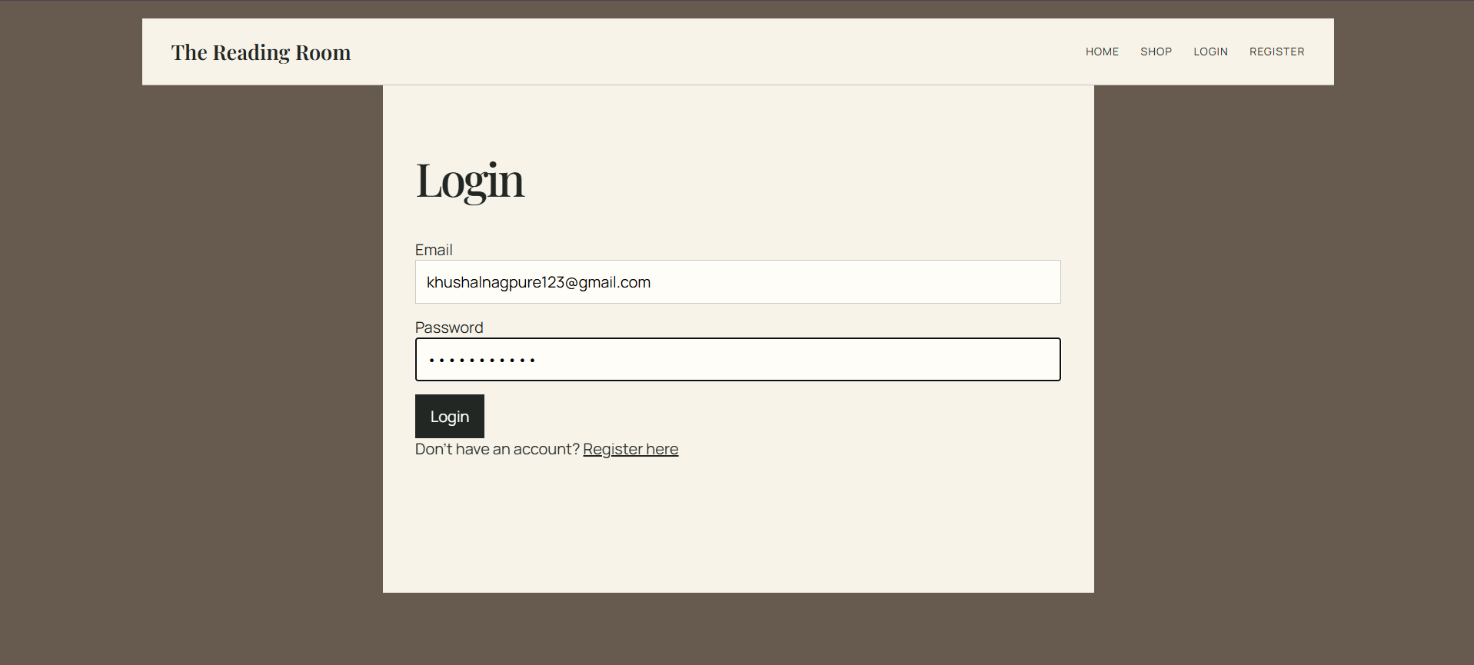
Search:

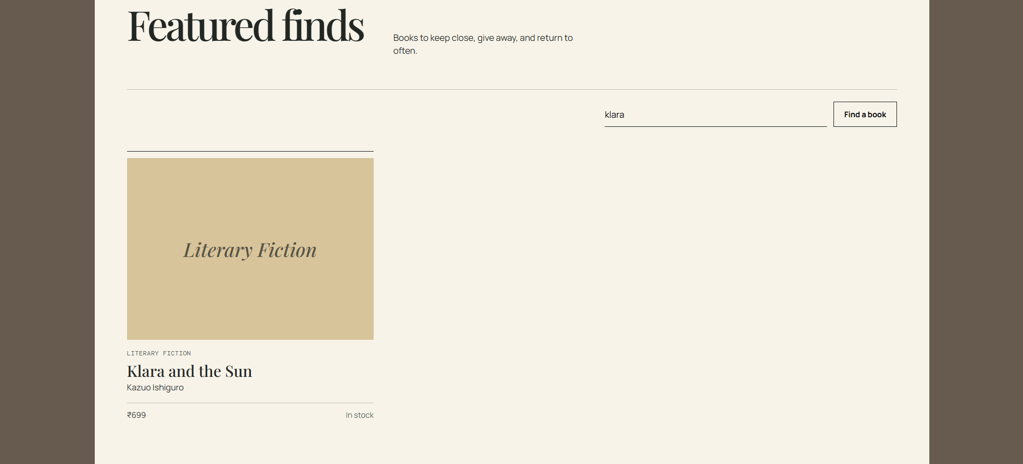

Frontpage:
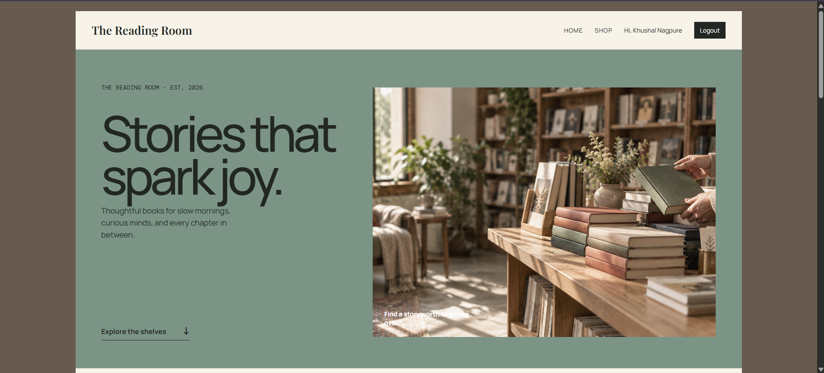
Register User:
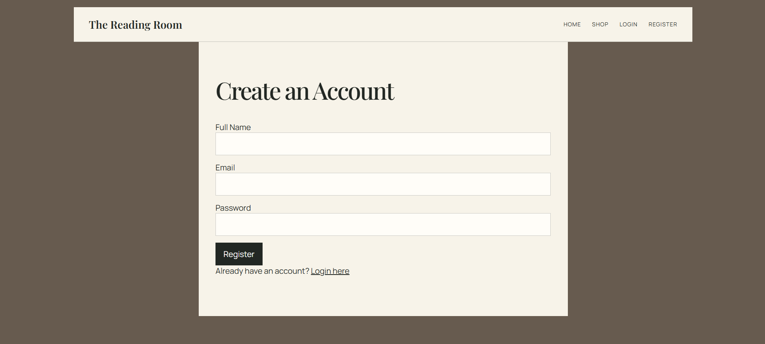

Books: 